**LAB 11**

**Q1) Write a program which contains a procedure named ThreeProd that displays the product of three numeric parameters passed through a stack.**

**Program:**

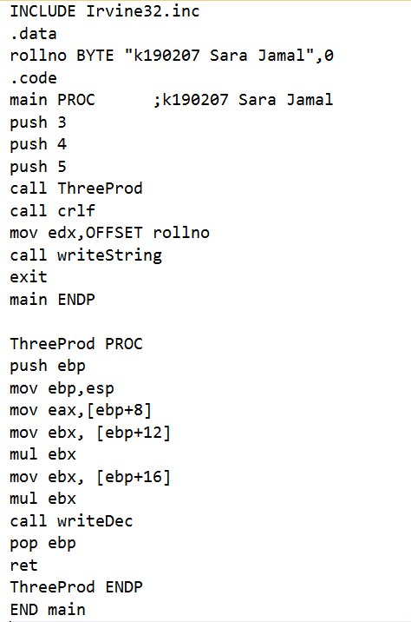

**Output:**

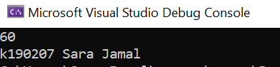

**Q2) Write a program that contains a procedure named Bubble Sort. The procedure must declare a local variable named temp. You have to sort the array of 5 elements (439, 7, 210, 75, 20, and 30).**

**Program:**

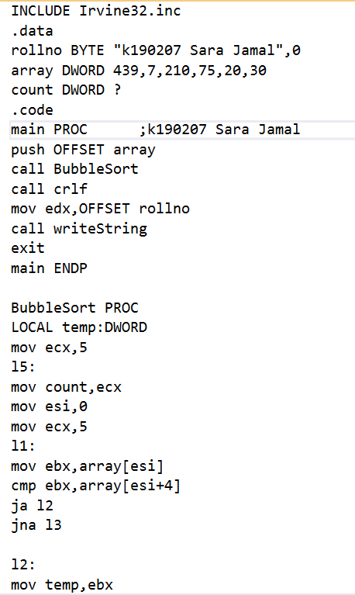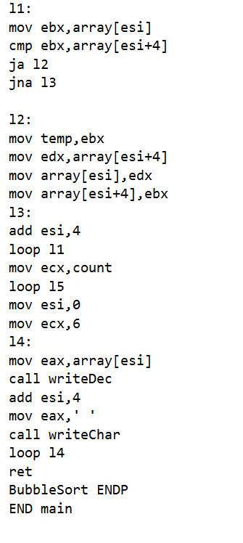

**Output:**

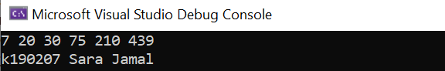

**Q3) Write a program to take 4 input numbers from the users. Then make two procedures CheckPrime and LargestPrime. The program should first check if a given number is a prime number or not. If all of the input numbers are prime numbers then the program should call the procedure LargestPrime.**

**CheckPrime: This procedure tests if a number is prime or not.**

**LargestPrime: This procedure finds and displays the largest of the four prime numbers.**

**Program:**

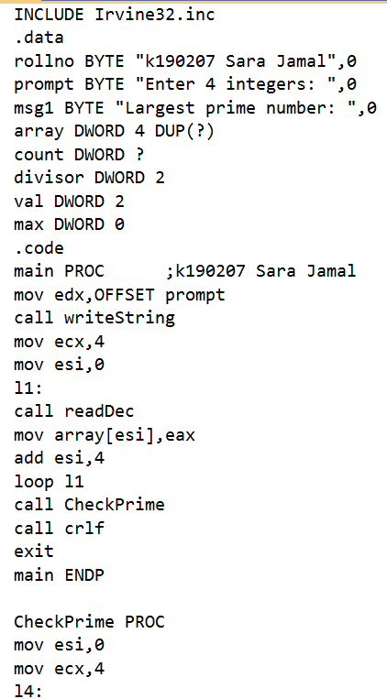 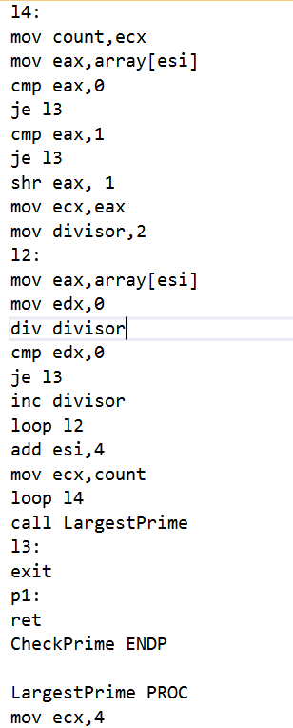

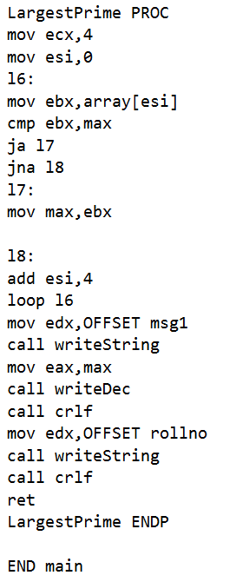

**Output:**

